Assignment 2

Information Systems 2B (INSY6212)

CommCare (BCA3 – Group 2)

Sashveer Lakhan Ramjathan (ST10361554), Shravan Ramjathan (ST10247982), Blaise Mikka de Gier (ST10249838), Uvaan Covenden (ST10022006)

# Table of Contents

Question 1………………………………………………………………………………………..Pages 2 - 5

Question 2……………………………………………………………………………………………….Page 5

Question 3……………………………………………………………………………….……..Pages 6 - 13

Question 4……………………………………………………………………………………..……..Page 14

Question 5……………………………………………………………………………….……………Page 14

Reference List…………………………………………………………………………….….Pages 15 - 17

# Question 1

## Q.1.1)

### 1. Ensures Systematic Performance Assessment

A standardised evaluation form ensures each project deliverable, and each activity is measured against predetermined criteria to prevent ad hoc reviews or biased assessments (Athuraliya, 2024). Through applying related questions and metrics, teams can monitor progress through all formative, ongoing, and summative phases to ensure no area falls through the cracks (Miljkovic, 2024).

### 2. Facilitates Informed Decision-Making

Collecting systematic feedback through a form provides project managers with well-defined visibility into areas of strength and weakness, facilitating data-driven changes before problems build up (Athuraliya, 2024). Quantifiable outcomes from the measurement process enable strategic planning for subsequent projects by assisting in budget and effort deployment where they will have the maximum impact (Burner, 2023).

### 3. Promotes Accountability and Stakeholder Engagement

Asking team members to fill in an evaluation form promotes ownership, in that each contributor is forced to think about his/her role and results (Athuraliya, 2024). Engaging sponsors and users during the evaluation phase through specific questions cultivates trust and guarantees broad perspectives will be captured (Indeed Editorial Team, 2025).

### 4. Captures Lessons Learned for Organisational Learning

A well-crafted form encourages teams to record what they did well and where they fell short, leaving a database of lessons learned to call upon in subsequent initiatives (Athuraliya, 2024). Incorporating such learning into organisational processes shortens development time, as subsequent teams avoid known problems and repeat verified methods (Khalid, Kitchen and Asuelimen, 2023).

### 5. Identifies Areas for Resource Optimisation and Efficiency

By tracking resource utilisation against milestones in the projects, managers can identify where time or budget overrun happened (Athuraliya, 2024). This information enables better allocation of staff, equipment, and budget in future projects, reducing wastage and optimising ROI (EvalCommunity, 2023).

## Q.1.2)

For our project, we have selected React Native. It is a widely adopted cross-platform framework, that streamlines development and deployment across Android and iOS platforms.

Cross-platform development deploys a common codebase across different operating systems, reducing time-to-market through reuse of effort across platforms (GeeksforGeeks, 2021). It achieves strict schedules through standardised development processes and minimised redundant testing (JetBrains, 2022). It poses challenges from the areas of performance constraints, feature gaps specific to the platform, and reliance on updates in frameworks (GeeksforGeeks, 2021). These challenges are addressed through careful design and platform selection of mature frameworks. From the user’s perspective, cross-platform solutions deliver consistency, increased reach across devices, and uninterruptible task continuation, with careful adaptation of the user interface maintaining native look-and-feel both across Android and iOS (JetBrains, 2022).

### Definition of Cross-Platform Development

#### Shared Codebase Approach

Cross-platform development is the process of creating applications from one shared pool of code to compile or interpret for various mobile operating systems like Android and iOS (GeeksforGeeks, 2021).

#### Platform-Agnostic Frameworks

Frameworks such as Flutter, React Native, and Xamarin abstract away OS differences, enabling developers to write business logic and the user interface once and deploy to any platform without rewriting for each OS (Białęcki, 2023).

### Meeting Project Timelines

#### Reduced Development Effort

By sharing as much as 90% of the same code across different platforms, cross-platform methods save considerable development time relative to simultaneous native projects, making possible one-click simultaneous release to both iOS and Android (Nitecki, 2024).

#### Simplified Testing and QA

A unified codebase means a smaller test matrix, teams test one application logic layer rather than separate native apps, shortening QA cycles and compressing overall schedules (Awati, 2023).

### Three Potential Risks

#### Performance Overheads

Cross-platform apps are at risk of runtime performance degradation from abstract layers and the invocation of bridges from native APIs to common code, both of which affect responsiveness in graphics-heavy situations (Borcherding, 2023).

#### Delayed Access to Platform Features

When Apple and Google unveil fresh OS capabilities, cross-platform frameworks usually take time to support them, leaving teams to adopt temporary workarounds or wait for updates to the frameworks (Nitecki, 2024).

#### UI/Fidelity Inconsistencies

Different design conventions (e.g. navigation, typography) from one platform to another cannot always be supported by generic components and thus result in a “one-size-fits-none” UX unless custom per-platform styling is utilised (GeeksforGeeks, 2021).

### Improving User Experience and Usability

#### Consistent Experience Across Devices

Users have a consistent interface and workflow whether they are using Android or iOS, lowering the cognitive load of device switching and reinforcing brand identity (UXPin, 2022).

#### Broader Audience Reach

Launching at the same time across various channels increases the potential user base without leaving any segment untouched and increases overall engagement and retention levels (Vasile Crudu, 2024).

#### Seamless Task Continuity

Mature frameworks enable device synchronisation and state preservation across devices (e.g. resume from mobile, pick up from tablet), creating seamless user experiences and greater satisfaction (Aleksandr Burenko, 2024).

## Q.1.3)

Listed below are the major deliverables (Gido et al., 2022) that would form part of our project charter:

1. System Architecture Documentation  
   A complete architectural blueprint of the app, including system components, requirements, and implementation specifications.
2. User Authentication and Management Module  
   A secure, tested module for user registration, login, and role-based access control (RBAC).
3. Real-Time Community Communication System  
   A functional alert and calendar system that enables real-time safety updates, incident reporting, and scheduling features.
4. User Interface Design Prototype  
   A finalised and tested UI design with accessibility features, offline support, and user-centric theming.
5. Quality Assurance Report  
   A compiled set of test results, including security analysis, functional tests, and user acceptance testing metrics.
6. Deployed Mobile Application and Maintenance Plan  
   The packaged mobile app deployed for public use, with post-launch support documentation and future update planning.

# Question 2

(Gido et al., 2022)

This question was completed using Microsoft Visio (Microsoft, 2025a). Please refer to the file submitted named *“INSY6212 CommCare - Q.2 (WBS)”.*

# Question 3

## Q.3.1)

(Gido et al., 2022)

This question was completed using Microsoft Project (Microsoft, 2025b). Please refer to the file submitted named *“INSY6212 Assignment 2 Q.3.1 - CommCare”.* Screenshots are included below.

**Indentured List – Expanded (1)**

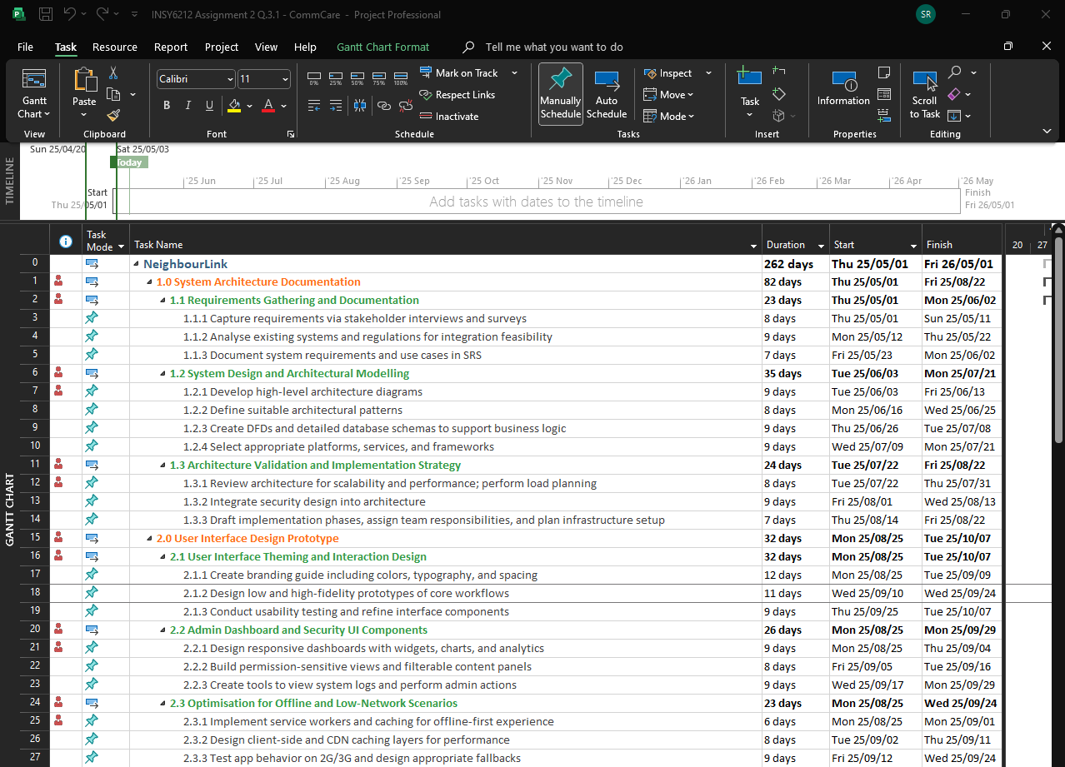

**Indentured List - Expanded (2)**

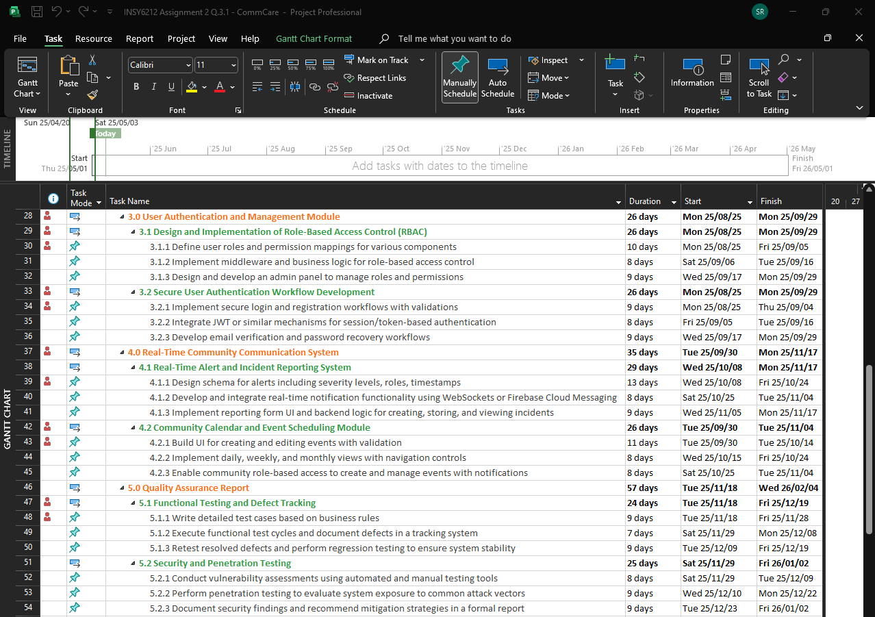

**Indentured List - Expanded (3)**

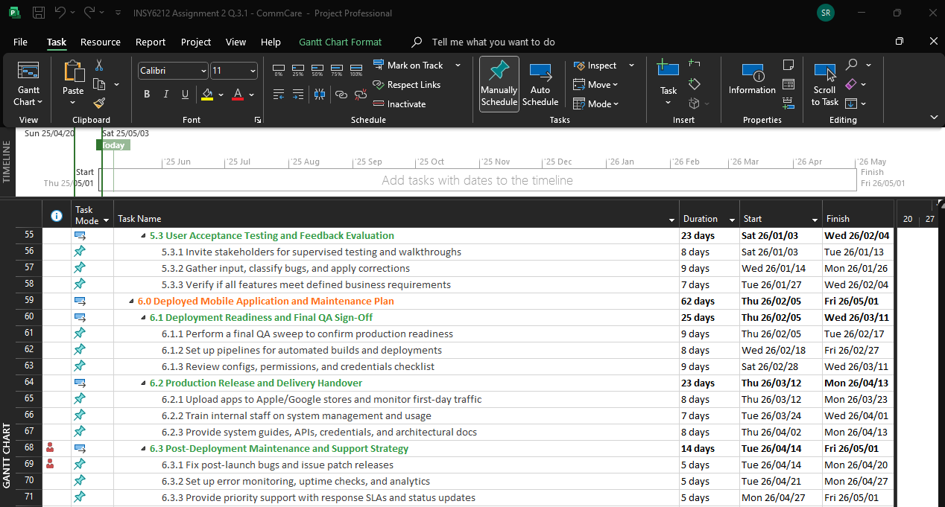

**Indentured List – Collapsed Level 3**

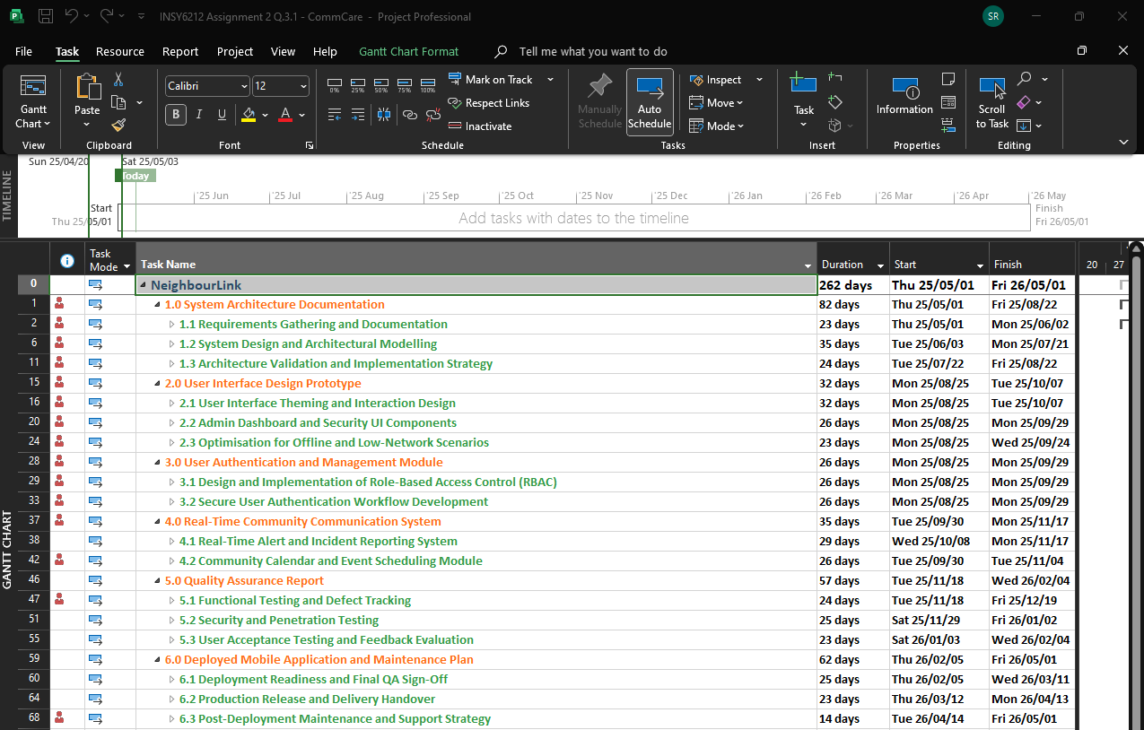

**Creation of resources / team member names**

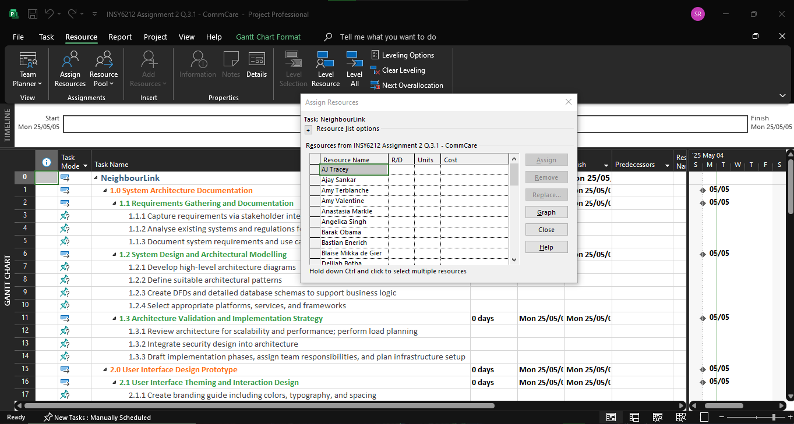

**Team member names captured – Resource Sheet (1)**

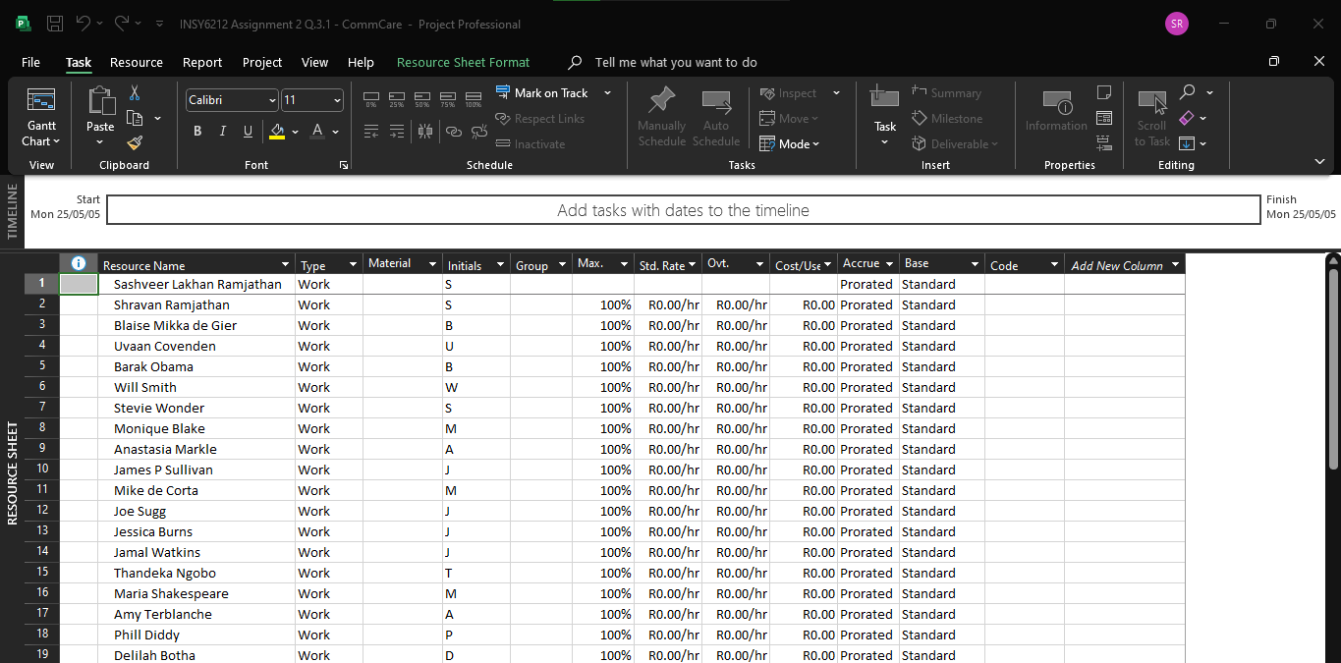

**Team member names captured – Resource Sheet (2)**

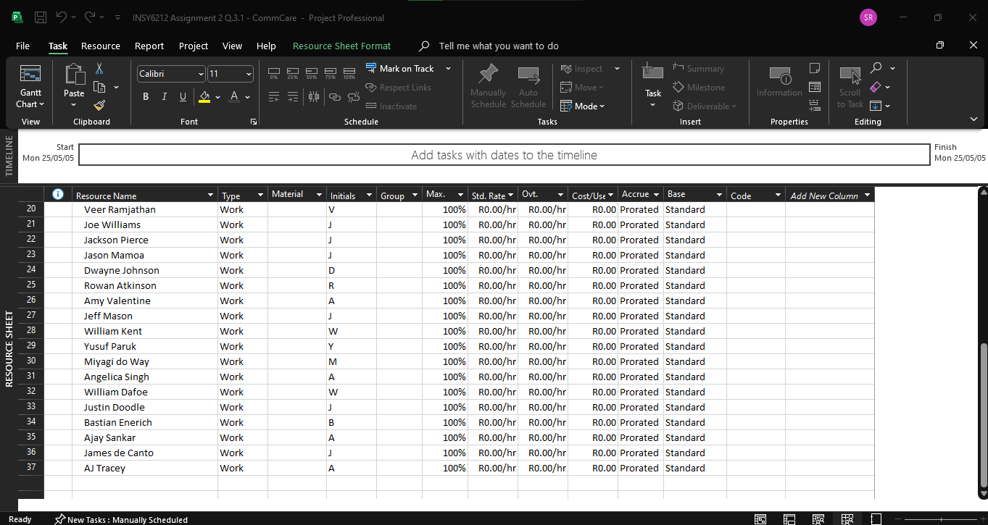

**Setting the project baseline**

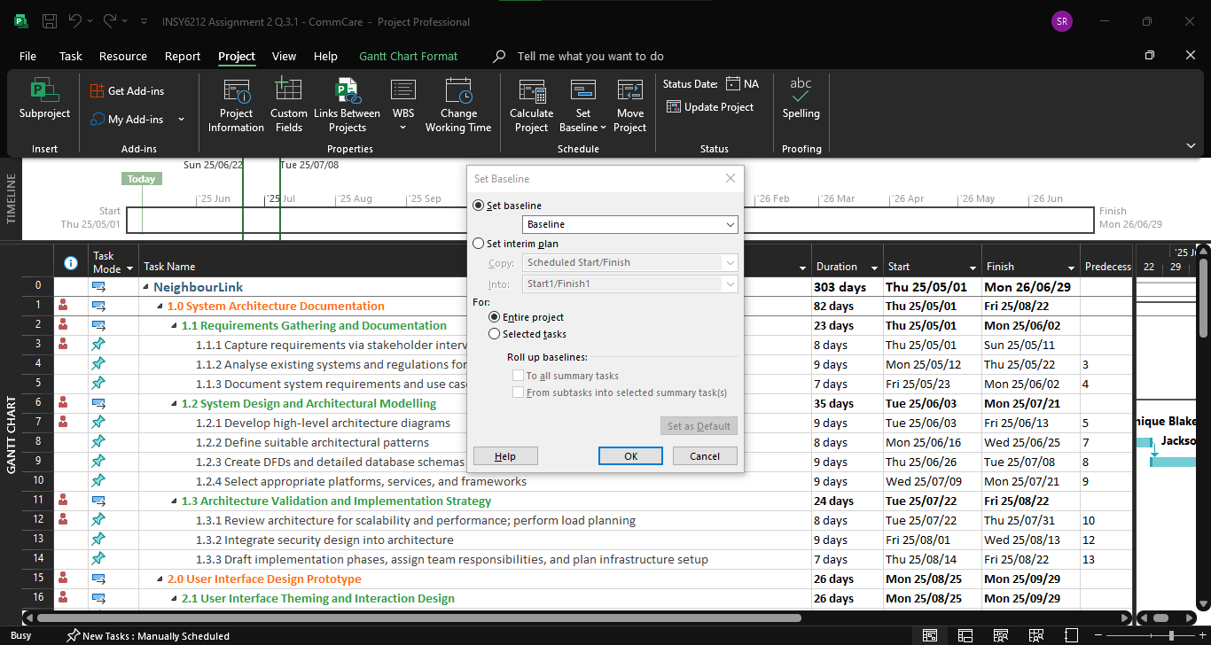

## Q.3.2)

This question was completed using Microsoft Project (Microsoft, 2025b) and GitHub (GitHub, 2025). A GitHub repository link is included below as well as screenshots for quick reference.

**GitHub Repository Link:**

<https://github.com/CommCare-INSY6212/Assignment-2-Screenshots.git>

**Microsoft Project Issue Log – Task Sheet View (1)**

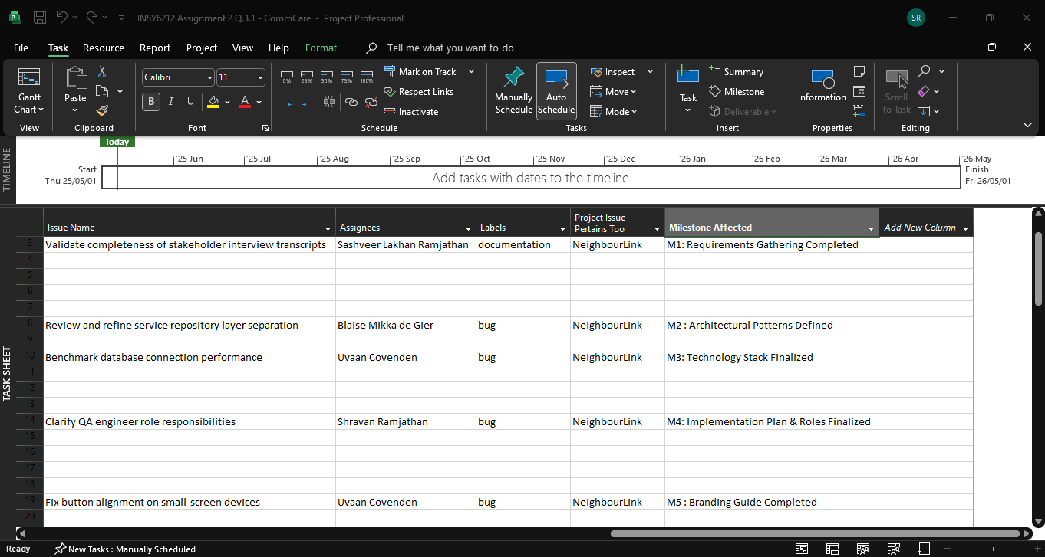

**Microsoft Project Issue Log – Task Sheet View (2)**

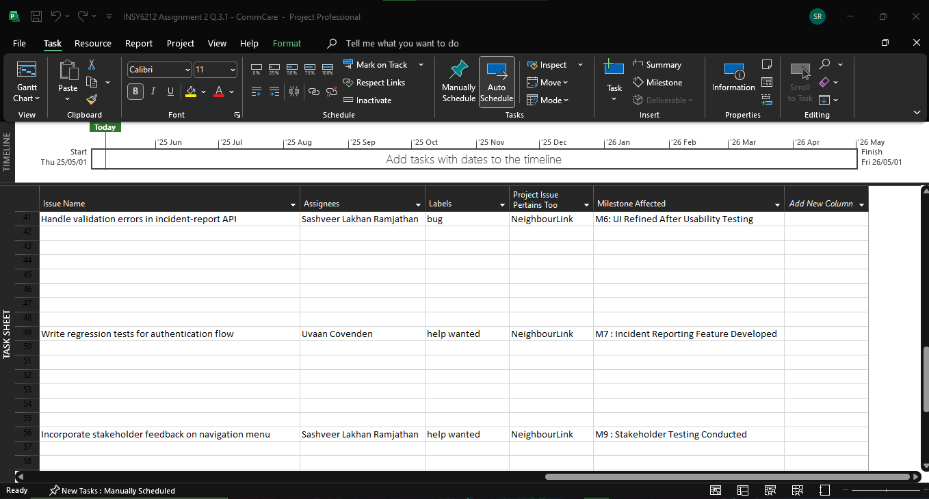

**Microsoft Project Issue Log – Task Sheet View (3)**

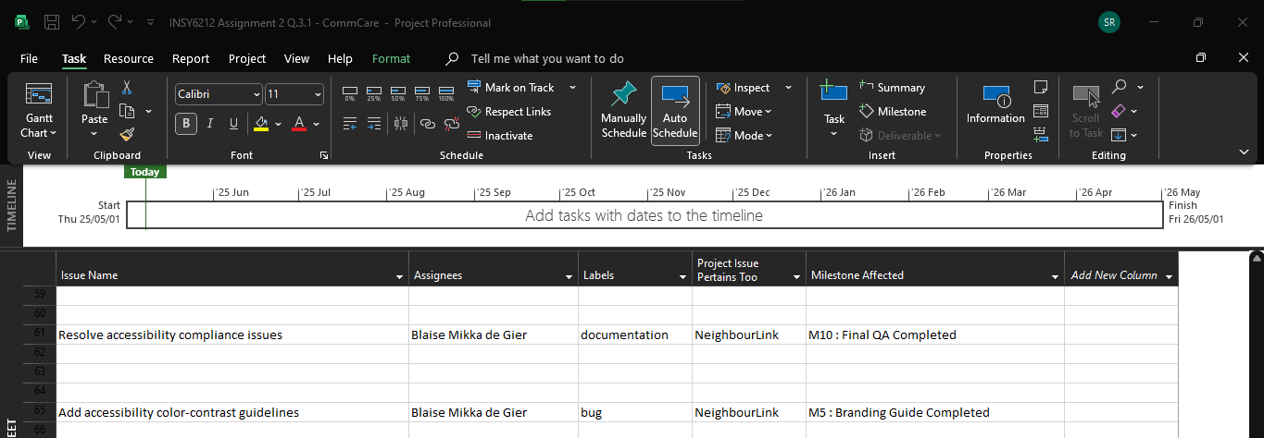

**GitHub Issue Log Items (Can be found in the repository provided above)**

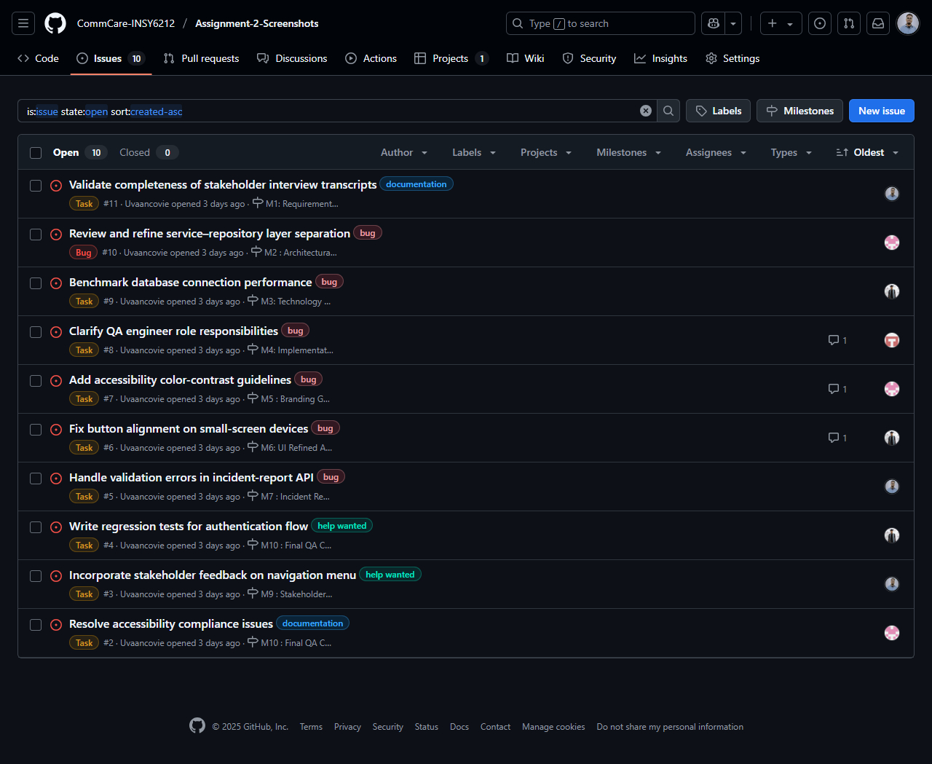

**GitHub Monthly Milestones List (Can be found in the repository provided above)**

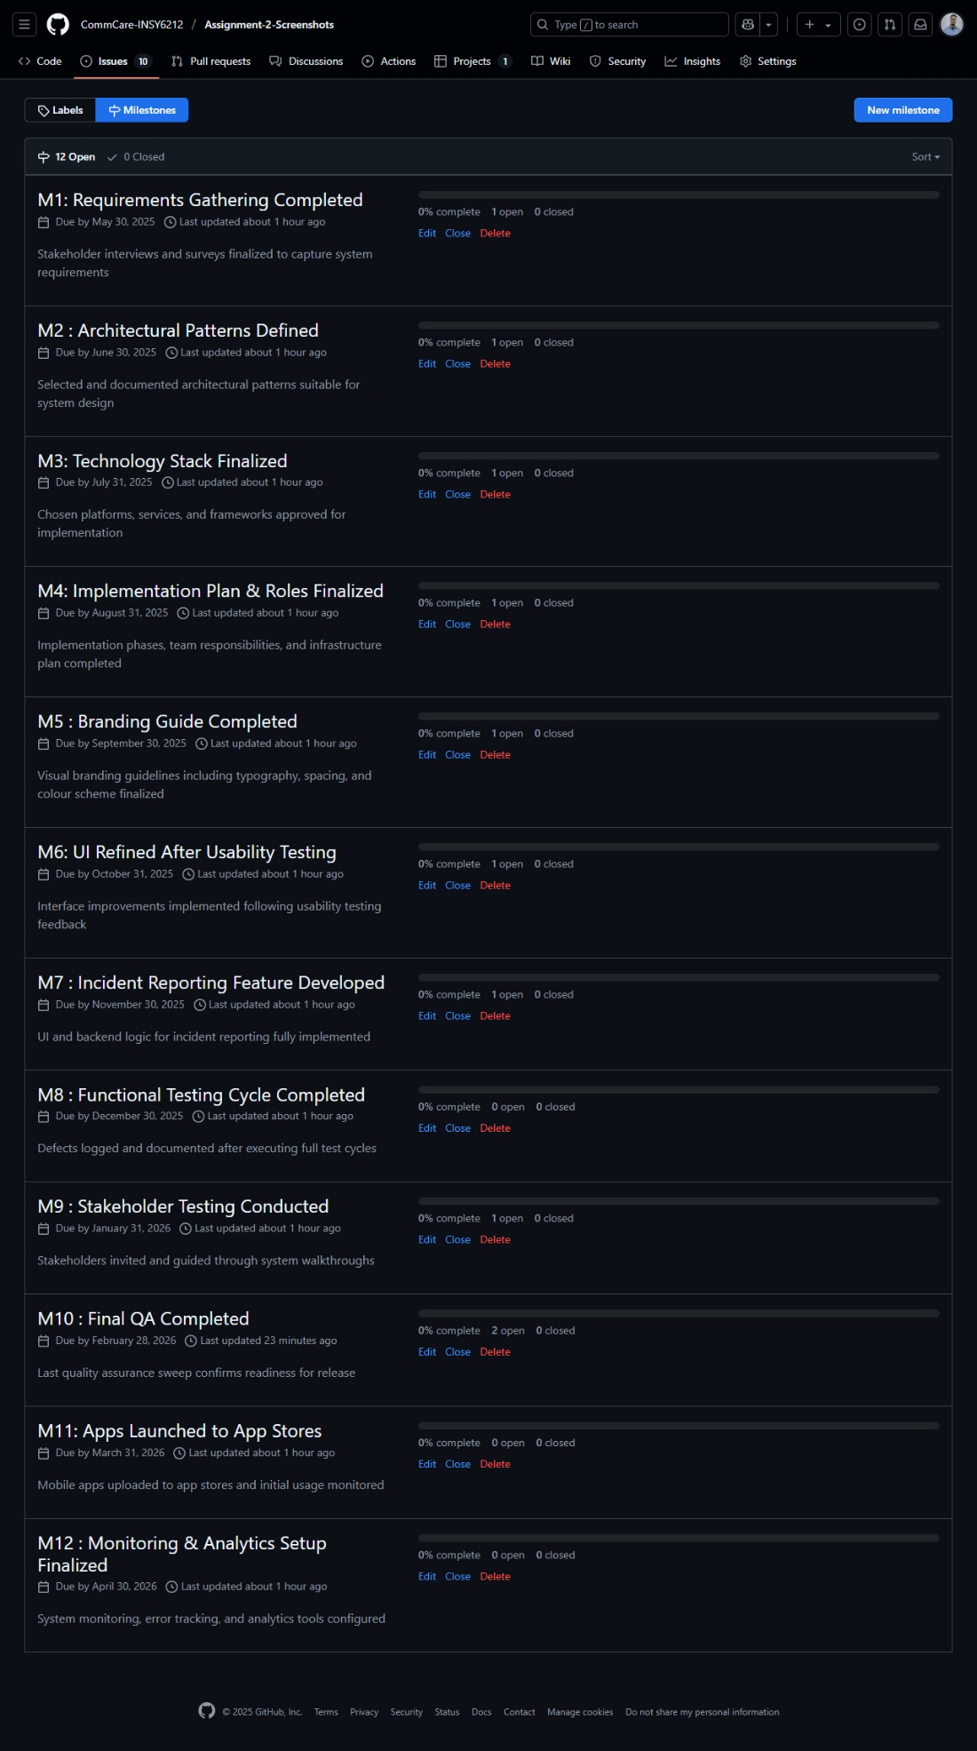

# Question 4

(Gido et al., 2022)

This question was completed using Microsoft Visio (Microsoft, 2025a). Please refer to the file submitted named *“INSY6212 A2 - Q.4 (CommCare) Network Diagram”*.

# Question 5

This is an individual task completed by each group member. Each member has submitted three peer evaluations and one self-reflection report. For reference our group members names are listed below:

* Sashveer Lakhan Ramjathan *(ST10361554)*
* Shravan Ramjathan *(ST10247982)*
* Blaise Mikka de Gier *(ST10249838)*
* Uvaan Covenden *(ST10022006)*

# Reference List

Aleksandr Burenko, 2024. Impact of Cross Platform App Development on User Experience. [online] Uran Company. Available at: <https://urancompany.com/blog/impact-of-cross-platform-app-development> [Accessed 7 May 2025].

Athuraliya, A., 2024. What is Project Evaluation? The Complete Guide with Templates | Creately. [online] creately.com. Available at: <https://creately.com/guides/project-evaluation/> [Accessed 7 May 2025].

Awati, R., 2023. What is cross-platform mobile development? - Definition from WhatIs.com. [online] SearchMobileComputing. Available at: <https://www.techtarget.com/searchmobilecomputing/definition/cross-platform-mobile-development> [Accessed 7 May 2025].

Białęcki, H., 2023. Cross-Platform App Development 101: What Is It and How Does It Work? | Monterail. [online] Monterail.com. Available at: <https://www.monterail.com/blog/cross-platform-app-development> [Accessed 7 May 2025].

Borcherding, D., 2023. The Pros and Cons of Cross-Platform Mobile App Development Frameworks. [online] Taazaa. Available at: <https://www.taazaa.com/cross-platform-mobile-app-development/> [Accessed 7 May 2025].

Burner, S., 2023. Project Evaluation: Steps, Benefits, and Common Mistakes. [online] ClickUp. Available at: <https://clickup.com/blog/project-evaluation/> [Accessed 7 May 2025].

EvalCommunity, 2023. Project evaluation. [online] EvalCommunity. Available at: <https://www.evalcommunity.com/career-center/project-evaluation/> [Accessed 7 May 2025].

GeeksforGeeks, 2021. Introduction to Cross Platform Mobile Application Development. [online] GeeksforGeeks. Available at: <https://www.geeksforgeeks.org/introduction-to-cross-platform-mobile-application-development/> [Accessed 7 May 2025].

Gido, J., Clements, J., Baker, R., Harinarain, N. and Eresia-eke, C., 2022. Successful Project Management in South Africa. Second ed. Cengage.

GitHub, 2025. GitHub. [online] GitHub. Available at: <https://github.com/github> [Accessed 8 May 2025].

Indeed Editorial Team, 2025. 6 Project Evaluation Templates (Plus Benefits and Tips). [online] Indeed Career Guide. Available at: <https://www.indeed.com/career-advice/career-development/project-evaluation-template> [Accessed 7 May 2025].

JetBrains, 2022. Kotlin Multiplatform Development Help. [online] Kotlin Multiplatform Development Help. Available at: <https://www.jetbrains.com/help/kotlin-multiplatform-dev/cross-platform-mobile-development.html> [Accessed 7 May 2025].

Khalid, S., Kitchen, S. and Asuelimen, E., 2023. Evaluation in project management: what you need to consider. [online] www.apm.org.uk. Available at: <https://www.apm.org.uk/blog/evaluation-in-project-management-what-you-need-to-consider/> [Accessed 7 May 2025].

Microsoft, 2025a. Flowchart Maker and Diagramming Software | Microsoft Visio. [online] www.microsoft.com. Available at: <https://www.microsoft.com/en-za/microsoft-365/visio/flowchart-software> [Accessed 5 May 2025].

Microsoft, 2025b. Microsoft Project for the Web | Manage Projects Online. [online] Microsoft.com. Available at: <https://www.microsoft.com/en-us/microsoft-365/planner/microsoft-project> [Accessed 6 May 2025].

Miljkovic, A., 2024. Project Evaluation: 5 Steps to Measuring Success (+ Template). [online] Plaky Blog. Available at: <https://plaky.com/blog/project-evaluation/> [Accessed 7 May 2025].

Nitecki, S., 2024. Cross-Platform Mobile Apps Development – Pros and Cons. [online] www.netguru.com. Available at: <https://www.netguru.com/blog/cross-platform-mobile-apps-development> [Accessed 7 May 2025].

UXPin, 2022. Cross-Platform Experience – An In-Depth Guide for Product Designers. [online] Studio by UXPin. Available at: <https://www.uxpin.com/studio/blog/cross-platform-experience/> [Accessed 7 May 2025].

Vasile Crudu, 2024. How does cross platform development impact user experience? [online] Moldstud.com. Available at: <https://moldstud.com/articles/p-how-does-cross-platform-development-impact-user-experience> [Accessed 7 May 2025].